2.3 | Verifying data integrity
Team Invincible
Shashank Reddy Bijjam,
Sushanth Bolisetti
Sharan Botta
Abhaya Suraj Chitti
Roshan Singu

School for Professional Studies,
Saint Louis University
IS – 5960 – 02: Masters Research Project (Fall 2025)
Prof. Maria Weber
October 21, 2025

AI-Enhanced Master’s Program Transformation – Student Success Dashboard
Data Collection Plan
Project Summary
Our project, Student Success Dashboard, aims to help students track their academic performance and receive AI-powered insights to support learning and engagement. The system collects data on study habits, attendance, exam scores, and motivation to identify trends and offer personalized feedback. This tool is designed to improve self-awareness among students and promote early academic intervention.
Goals and Objectives
The main goal is to create a smart dashboard that provides real-time visuals of student performance. We also aim to integrate an AI recommendation feature that gives short insights such as “Keep up the good work” or “You may need to improve your attendance.” The system will help students understand their progress, improve engagement, and support academic success.
Research Questions / System Objectives
- How can student data be used to predict performance and risk levels?
- What metrics (attendance, study hours, motivation) impact student grades the most?
- How can AI-generated insights improve student self-management and academic outcomes?
Type of Data Needed
We used structured quantitative data, including:
- Academic details (attendance, study hours, exam scores, final grades)
- Behavioral metrics (motivation, engagement, stress)
- Course enrollment and feedback records
- AI-generated insight messages
Data Sources
- Primary Source: Kaggle – Student Performance Dataset (https://www.kaggle.com/datasets/adilshamim8/student-performance-and-learning-style), which contains over 14,000 student records. It includes information about demographics, engagement, and academic performance. For privacy and security, all data is anonymized.
- Secondary Source (Simulated): Additional supporting tables (Student Profiles, Faculty Feedback, AI Insights, Engagement Logs, and Course Enrollments) were created using Python Faker and NumPy libraries.
Data Collection and Generation Method
We used Python to:
- Merge Kaggle’s real data with simulated tables.
- Assign unique Student_IDs.
- Generate realistic fields like names, emails, programs, course enrollments, and weekly engagement logs.
- Add AI-generated insight messages such as “Excellent progress!” or “Consider improving attendance.”
All synthetic data was generated between January 1, 2024, and October 20, 2025, covering four academic semesters.

Collected Dataset
Dataset Overview
The final dataset combines Kaggle data (14,003 rows) with simulated extensions:
- Student_Profile.csv – 14,003 records
- Student_Performance.csv – 14,003 records
- Course_Enrollment.csv – 14,003 records
- Faculty_Feedback.csv – 14,003 records
- AI_Insights.csv – 14,003 records
- Engagement_Log.csv – 14,003 records
Each dataset is linked by Student_ID. The structure allows both student-level analytics and dashboard visualizations.
Data Dictionary (Main Fields)
Field Name | Type | Description
Student_ID | String | Unique student identifier
Name | String | Student full name
Program | String | Student’s academic program
StudyHours | Integer | Weekly study hours
Attendance | Integer | Class attendance percentage
Motivation | Integer | Self-reported motivation score
StressLevel | Integer | Self-reported stress score
ExamScore | Integer | Latest exam score
FinalGrade | String | Letter grade (A–F)
Feedback_Text | String | Faculty feedback comments
Risk_Level | String | AI-generated performance risk level
Message | String | AI’s personalized recommendation
Week | Integer | Academic week number (1–16)
Login_Count | Integer | Weekly dashboard login frequency
Dashboard_Clicks | Integer | Interactions on the dashboard
Time_Spent | Integer | Time spent using the dashboard (minutes)
Data Source and Collection Dates
- Kaggle Dataset: Collected February 2025
- Simulated Dataset: Generated October 2025
- Date Range Covered: January 1, 2024, and October 20, 2025 (four semesters)

Data Summary Report
Dataset Description
The dataset is structured, cleaned, and stored in CSV format. Each table includes 14,003 records and multiple relationships established via Student_ID. It supports dashboards, AI model training, and visualization.
How the Data Was Obtained or Generated
- Kaggle data was imported using pandas.read_csv().
- Synthetic data was generated using Python’s Faker, NumPy, and pandas libraries.
- Fields like “AI Insights,” “Engagement Logs,” and “Feedback” were created to make the dataset more realistic and suitable for student-focused dashboards.
Data Preparation Steps
- Data Cleaning:
  - Checked for duplicates and missing values.
  - Normalized columns (like standardizing letter grades, attendance percentages).
- Transformation:
  - Merged Kaggle and synthetic tables using Student_ID.
  - Added calculated fields such as Risk_Level based on FinalGrade and Attendance.
- Integrity Verification:
  - Ensured all Student_IDs matched across tables.
  - Validated numeric ranges (e.g., StudyHours between 0–50, Attendance between 0–100).
Limitations or Gaps
- AI insights are simulated and not based on real predictions yet.
- Some values, like faculty feedback, are randomly generated for testing.
- Real-time integration from a Learning Management System (LMS) has not yet been implemented.
How This Data Supports the Capstone Project
This dataset is the foundation for:
- Dashboard Design: Visualizing student performance and engagement.
- AI Integration: Training a simple model to generate performance recommendations.
- Decision-Making: Helping students monitor their progress and identify areas of improvement.
The dataset aligns with the architecture and ERD shown below, linking students, courses, feedback, and AI insights into a single, connected system.
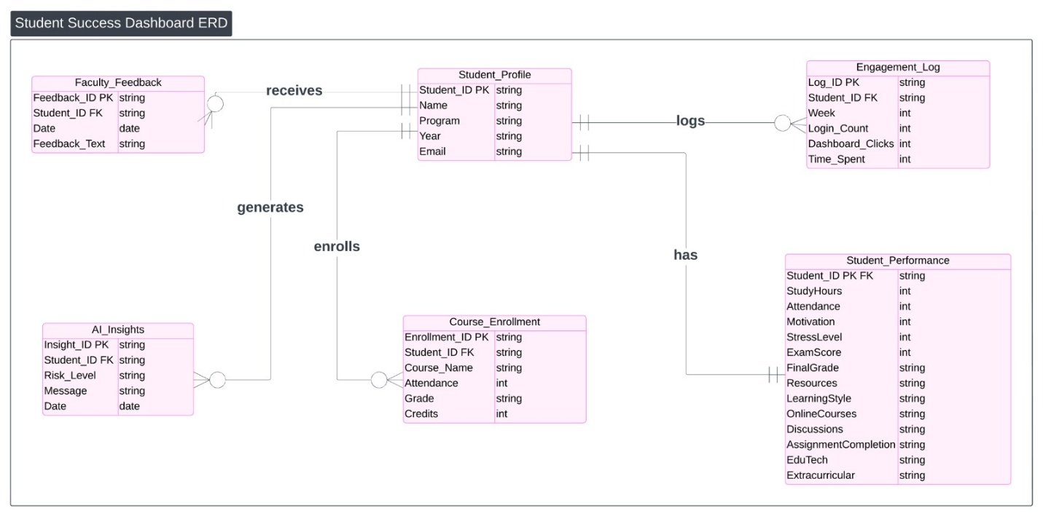
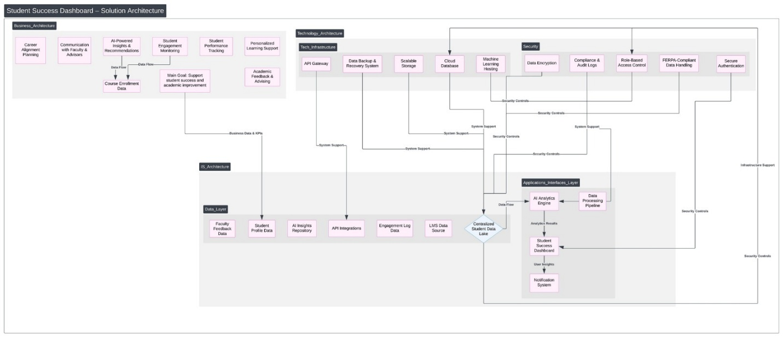
Ethical Considerations
- All data is synthetic or anonymized, ensuring no real student information is used.
- The design follows FERPA standards to protect educational data.
- AI-generated insights are meant to guide students positively and avoid bias or negative labeling.
Summary
Our team created a realistic, well-structured dataset combining real Kaggle data and simulated student data to support the Student Success Dashboard. It represents how AI and analytics can work together to provide personalized, ethical, and data-driven academic support for students.

